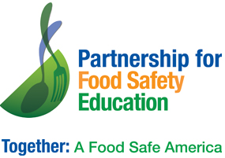
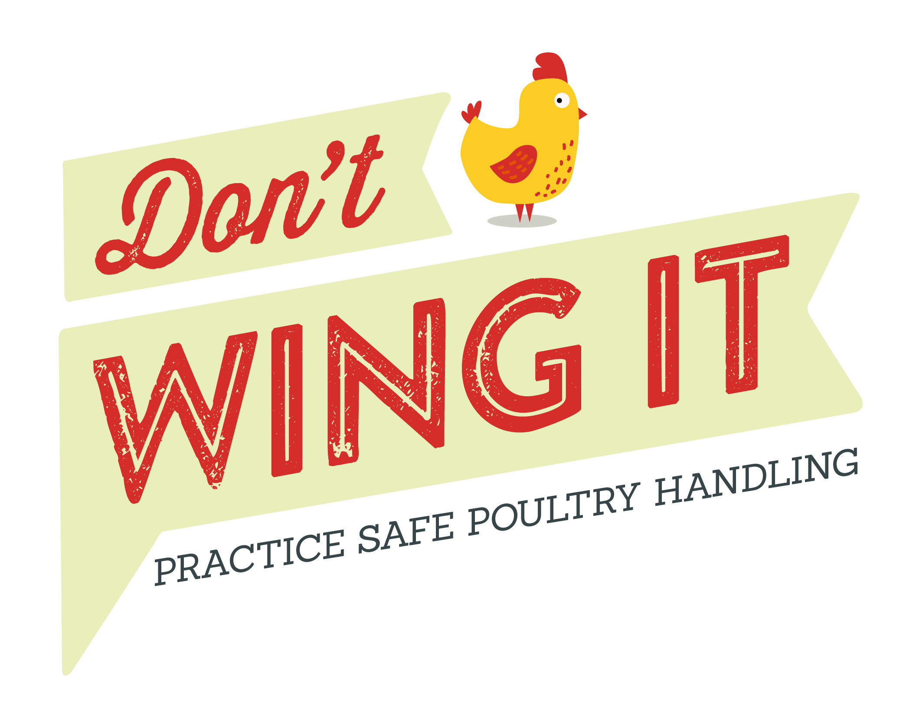Don’t Wing It Blog Post – cut, paste, customize!

Know the Do’s and Don’ts of Safe Poultry Handling

While many consumers are aware of the risks of consuming raw or undercooked poultry, fewer realize that the steps they’re taking when handling poultry in the grocery store and at home could be putting them at risk for contracting a foodborne illness.

Contaminated food sickens nearly 48 million people in the United States every year—that’s 1 in 6.¹ In 2014, chicken was linked to 23 outbreaks, and is the food category responsible for the second-largest number of foodborne illnesses.²

Salmonella and Campylobacter are two common germs that can cause foodborne illness. Children and seniors are particularly susceptible to the dangers of food contaminated with bacteria.

Children are more likely to get sick from germs that cause foodborne illness because their immune systems are less developed and less able to fight infection.² After the age of 75, many adults have weakened immune systems, increasing the risk of contracting foodborne illness from germs like Salmonella and Campylobacter.³

Foodborne illness usually causes a stomachache, and in some cases it can lead to kidney failure or other chronic long-term health problems.

It’s essential that parents and seniors pay close attention to proper food handling and hand washing when preparing poultry.

Recent research showed that consumers were taking actions at the grocery store and at home that increased their risk of foodborne illness from raw poultry.⁴ Based on this research the non-profit Partnership for Food Safety Education and _____your org name _______ want to remind consumers of important and easy-to-follow steps to help keep you and your family food safe.

In Store: Don’t Touch

DISINFECT YOUR SHOPPING CART HANDLE
Use disinfectant wipes on surfaces, especially handlebar and child seat.

PLACE POULTRY IN PLASTIC BAG
Use plastic bags provided at meat counter to help avoid cross-contamination. Cover your hand with a plastic grocery bag when grabbing raw poultry from the meat case!

USE HAND SANITIZER
Use hand sanitizer after touching raw and packaged poultry if soap and water are not available.

At Home: Don’t Touch

PLACE IN THE FRIDGE OR FREEZER
Keep poultry in plastic bag and place on a low shelf to prevent leakage from contaminating other foods.

WASH HANDS BEFORE AND AFTER HANDLING
Use warm water and soap to clean hands and surfaces that have potentially come in contact with poultry or its juices.

At Home: Check Temp

THAW IN THE FRIDGE
Keep poultry at or below 40 ˚F when thawing.

USE A FOOD THERMOMETER
Cook poultry to a safe temperature of 165 ˚F to kill harmful bacteria.

Think Before You Rinse!
Rinsing poultry increases the chances of spreading raw juices around your kitchen.

Remember, cooking to 165 ˚F is the ONLY way to kill bacteria that can cause foodborne illness.

Download Don’t Wing It consumer brochures for Parents and for Seniors at www.fightbac.org.

1 "Estimates of Foodborne Illness in the United States." Centers for Disease Control and Prevention. 15 July 2016.
2. CDC. Foodborne Diseases Active Surveillance Network (FoodNet): FoodNet Surveillance Report for 2012 (Final Report). Atlanta, Georgia: U.S. Department of Health and Human Services, CDC. 2014.
3. Center for Food Safety and Applied Nutrition. "People at Risk of Foodborne Illness - Food Safety for Older Adults." U S Food and Drug Administration Home Page. Center for Food Safety and Applied Nutrition, Sept. 2011.
4. Donelan, A., Chambers, D.H., Chambers, E IV, Godwin, S., and Cates, S. 2016. Consumer poultry handling behaviors in the grocery store and in-home storage. Journal of Food Protection 79(4):584-588.

###

