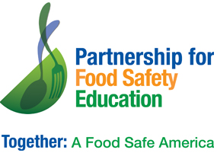
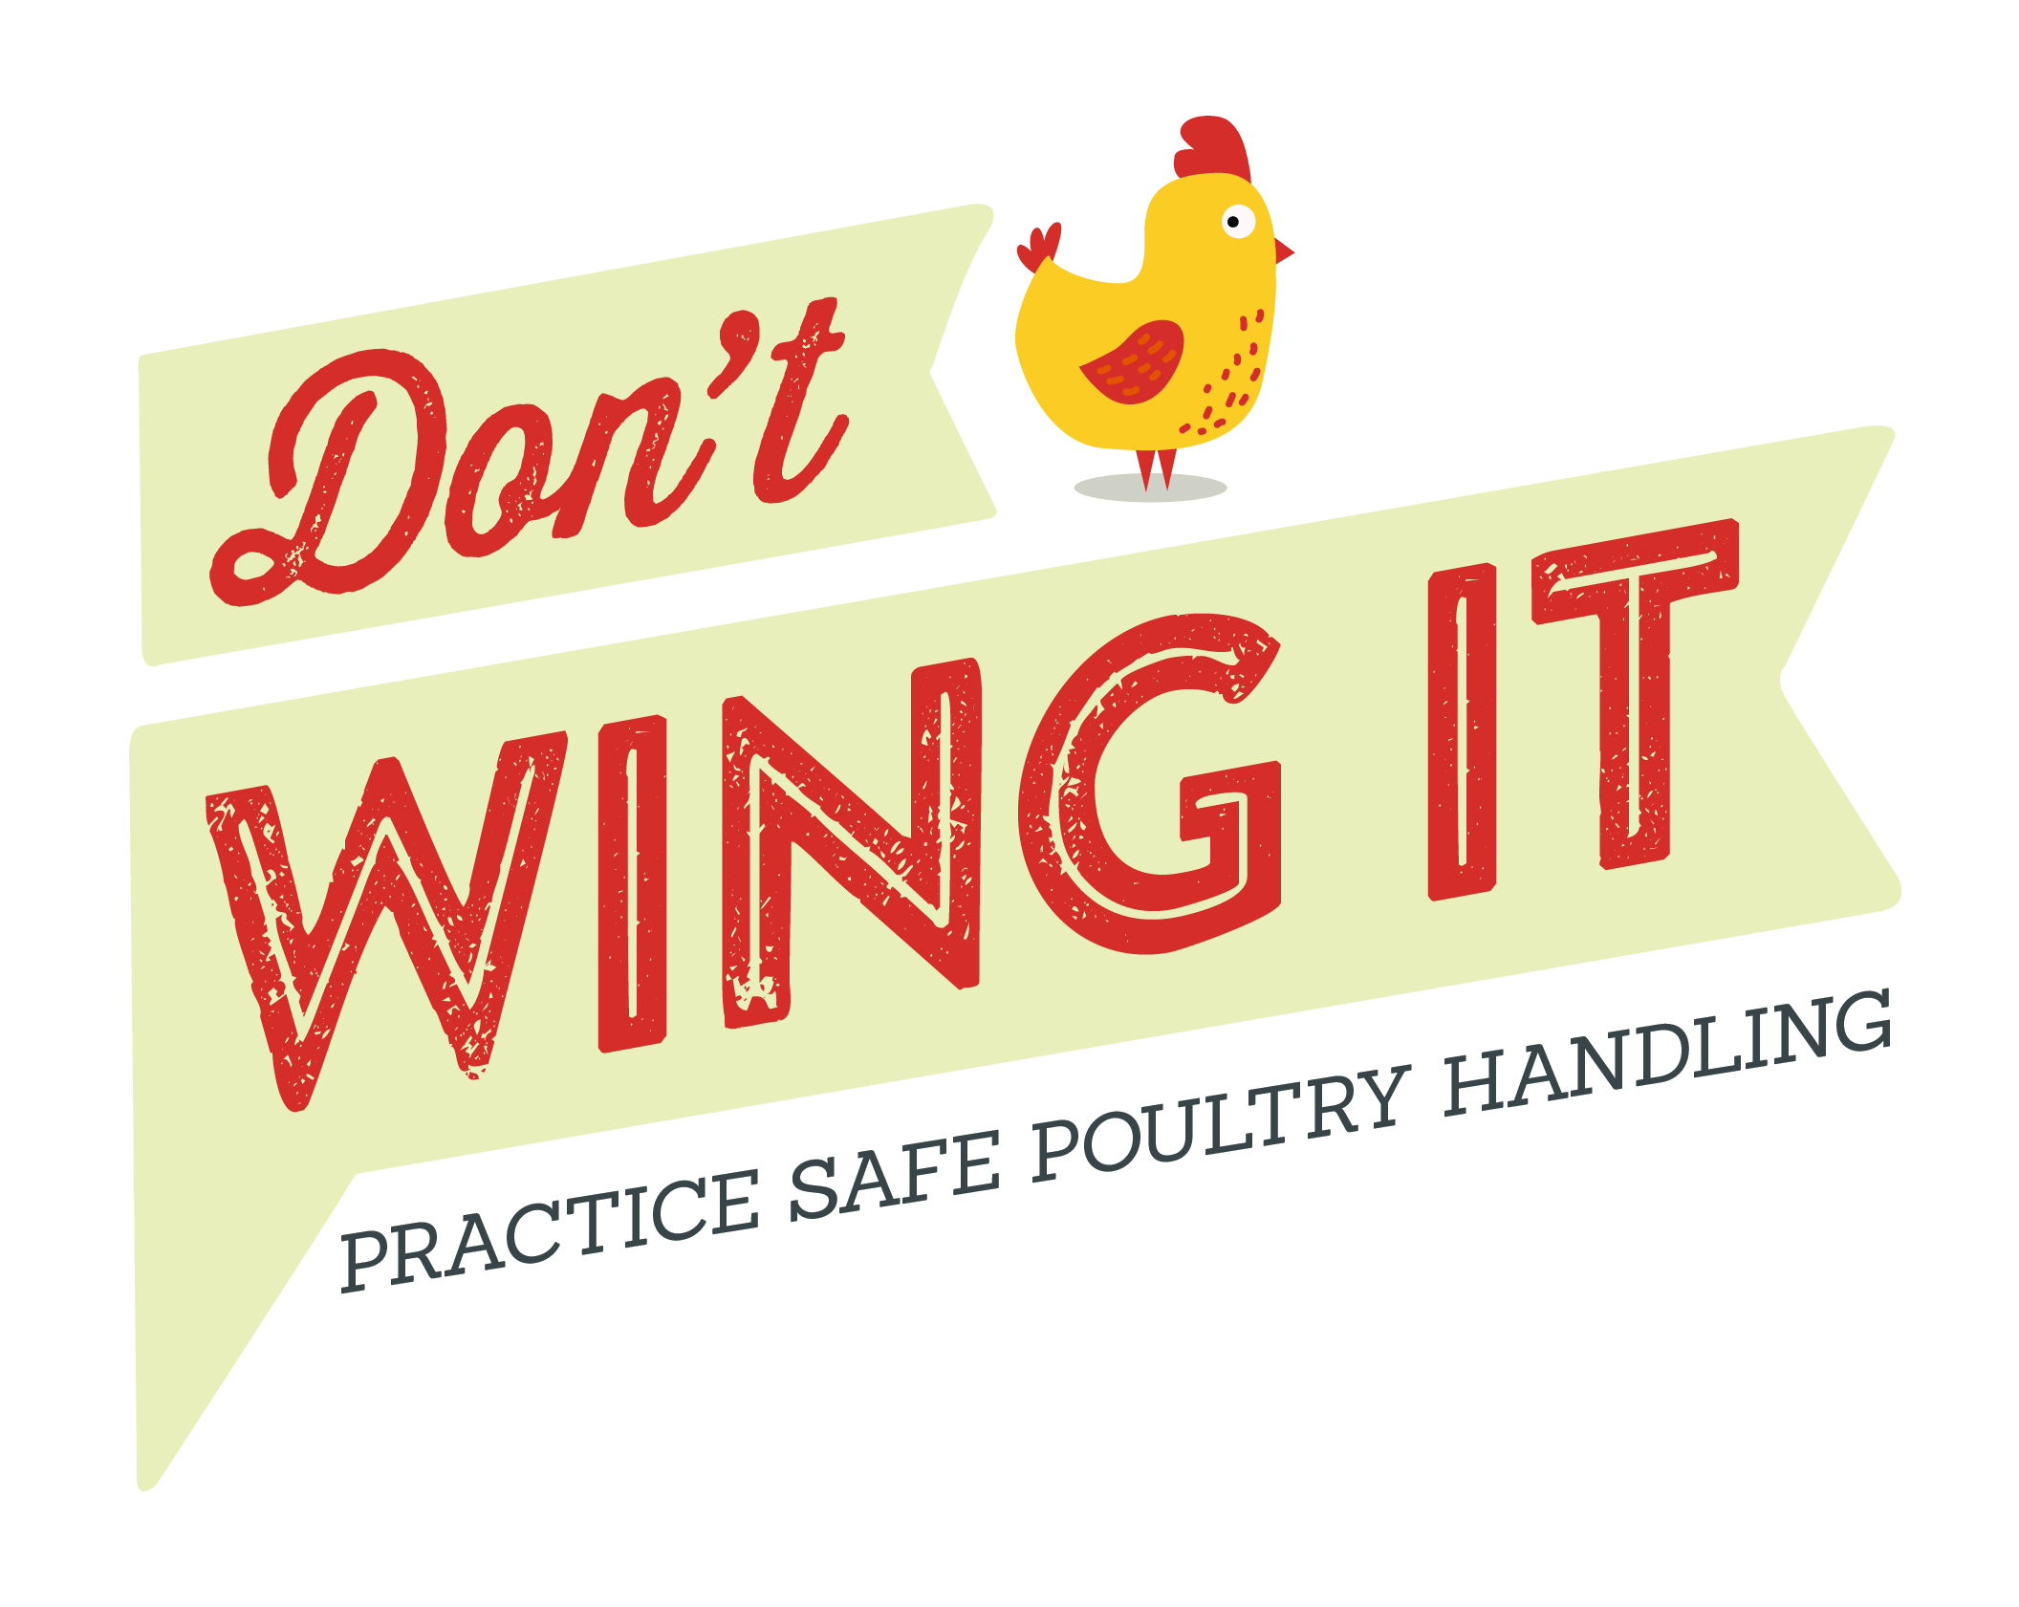
Don’t Wing It E-Mail template – cut, paste, customize!

BAC FIGHTERS! —Use the content in this email to educate your community leaders about the importance of sharing consumer poultry safety tips.

Share the Do’s and Don’ts of Touch and Temp for Safe Poultry Handling

In 2014, chicken was linked to 23 outbreaks and is the food category responsible for the second-largest number of foodborne illnesses. Contaminated food sickens nearly 48 million people in the United States every year—that’s 1 in 6.¹

Recent research observed consumers as they purchased and brought home raw poultry products.²

The study found consumers taking actions that could lead to the cross-contamination of germs from raw poultry.
• Only 25% of consumers bagged their poultry selections at the store
• A majority touched their cart immediately after handling poultry
• When consumers brought a poultry product home, nearly 60% did not store it in a plastic bag, increasing the chances of contaminating kitchen surfaces.

With the new tools of Don’t Wing It, it’s easier than ever to ensure your community, customers and patients are armed with the important knowledge they need to help prevent foodborne illness.

Share these important and easy-to-follow steps from the Partnership for Food Safety Education—and help keep families in your community food-safe!

In Store: Don’t Touch

DISINFECT YOUR SHOPPING CART HANDLE
Use disinfectant wipes on surfaces, especially handlebar and child seat.

PLACE POULTRY IN PLASTIC BAG
Use plastic bags provided at meat counter to help avoid cross-contamination. Cover your hand with a plastic grocery bag when grabbing raw poultry from the meat case!

USE HAND SANITIZER
Use hand sanitizer after touching raw and packaged poultry if soap and water are not available.

At Home: Don’t Touch

PLACE IN THE FRIDGE OR FREEZER
Keep poultry in plastic bag and place on a low shelf to prevent leakage from contaminating other foods.

WASH HANDS BEFORE AND AFTER HANDLING
Use warm water and soap to clean hands and surfaces that have potentially come in contact with poultry or its juices.

At Home: Check Temp

THAW IN THE FRIDGE
Keep poultry at or below 40 ˚F when thawing.

USE A FOOD THERMOMETER
Cook poultry to a safe temperature of 165 ˚F to kill harmful bacteria.

Think Before You Rinse!
Rinsing poultry increases the chances of spreading raw juices around your kitchen.

Remember, cooking to 165 ˚F is the ONLY way to kill bacteria that can cause foodborne illness.

Download Don’t Wing It consumer brochures for Parents and for Seniors at www.fightbac.org.

Visit FightBac.org for more information and to download Don’t Wing It brochures and other educational materials you can distribute to help everyone stay food safe.

1. "Estimates of Foodborne Illness in the United States." Centers for Disease Control and Prevention. 15 July 2016.
2. Donelan, A., Chambers, D.H., Chambers, E IV, Godwin, S., and Cates, S. 2016. Consumer poultry handling behaviors in the grocery store and in-home storage. Journal of Food Protection 79(4):584-588.

