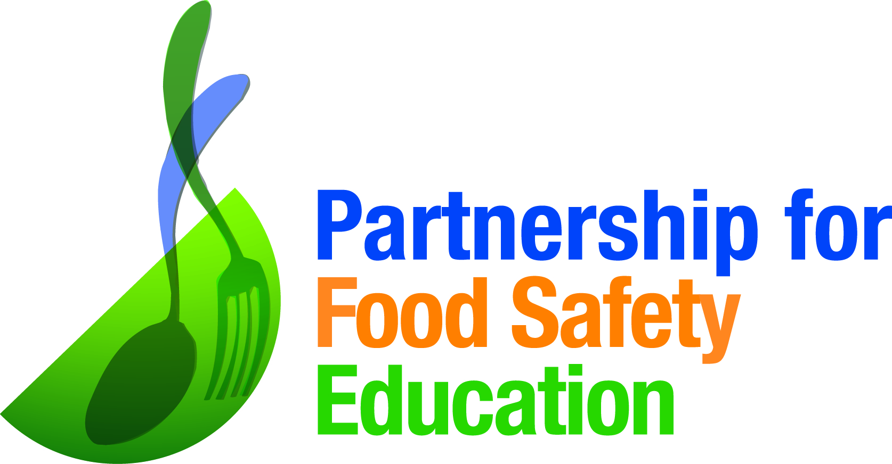

GO 40 °F OR BELOW
A Cold Fridge Will Help You Reduce Your Risk of Foodborne Illness

Why do pregnant women need to be extra vigilant with home food safety? When pregnant, a woman’s immune system is reduced. This places her and her unborn baby at increased risk of contracting a foodborne illness. Certain foods like raw sprouts, smoked seafood, deli meats, hot dogs, soft cheeses and unpasteurized dairy products can be especially risky for pregnant women. Each year, about one in seven (14%) cases of Listeriosis, a common foodborne illness, occurs during pregnancy.¹ Listeriosis can pass from pregnant women to their fetuses and newborns, which can lead to miscarriages, stillbirths and even newborn deaths. A pregnant woman is 10 times more likely to contract Listeriosis than is another healthy adult.
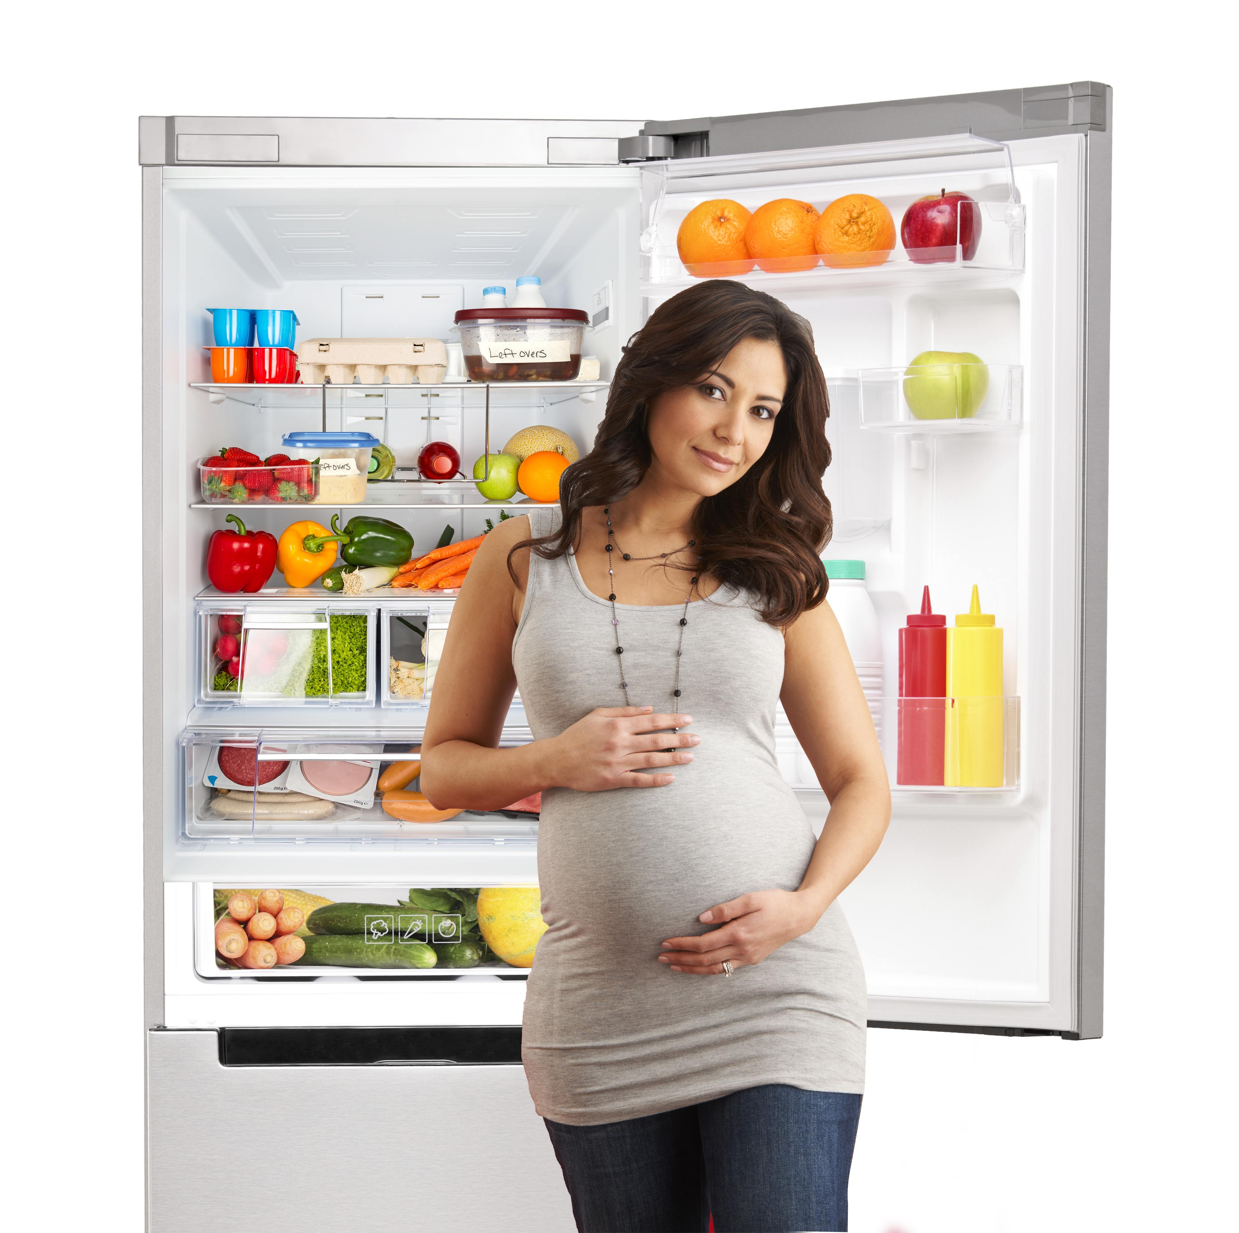
DON’T WORRY! THERE’S GOOD NEWS!

Simple solutions like making sure the refrigerator is set at the right temperature could make all the difference. According to a risk assessment produced by the US Food and Drug Administration and the US Department of Agriculture, refrigeration at 40 °F or below is one of the most effective ways to reduce the risk of foodborne illness. The assessment found that the predicted number of cases of Listeriosis would be reduced by more than 70% if all home refrigerator temperatures did not exceed 41 °F. The only way to be sure the home refrigerator is at or below the recommended temperature of 40 °F or below is to measure the temperature with a refrigerator thermometer. This type of thermometer is usually a separate tool that stays in the refrigerator and displays the actual temperature.

When you understand the cause of foodborne illness and how to prevent it, you can arm yourself with the right tools to protect yourself.

The Partnership for Food Safety Education’s new GO 40 °F OR BELOW campaign was launched to educate consumers, like you, about the importance of home refrigeration reducing the risk of foodborne illnesses. To learn more about how you can protect your family and friends from foodborne illness, and to download a GO 40 °F OR BELOW brochure, visit www.fightbac.org.

The Partnership for Food Safety Education delivers trusted, science-based behavioral health messaging and a network of resources that support consumer in their efforts to reduce risk of foodborne infection.

#Go40orBelow to keep food out of the “danger zone” and follow us @Fight_BAC for more food safety tips!

¹ Center for Disease Control and Prevention

