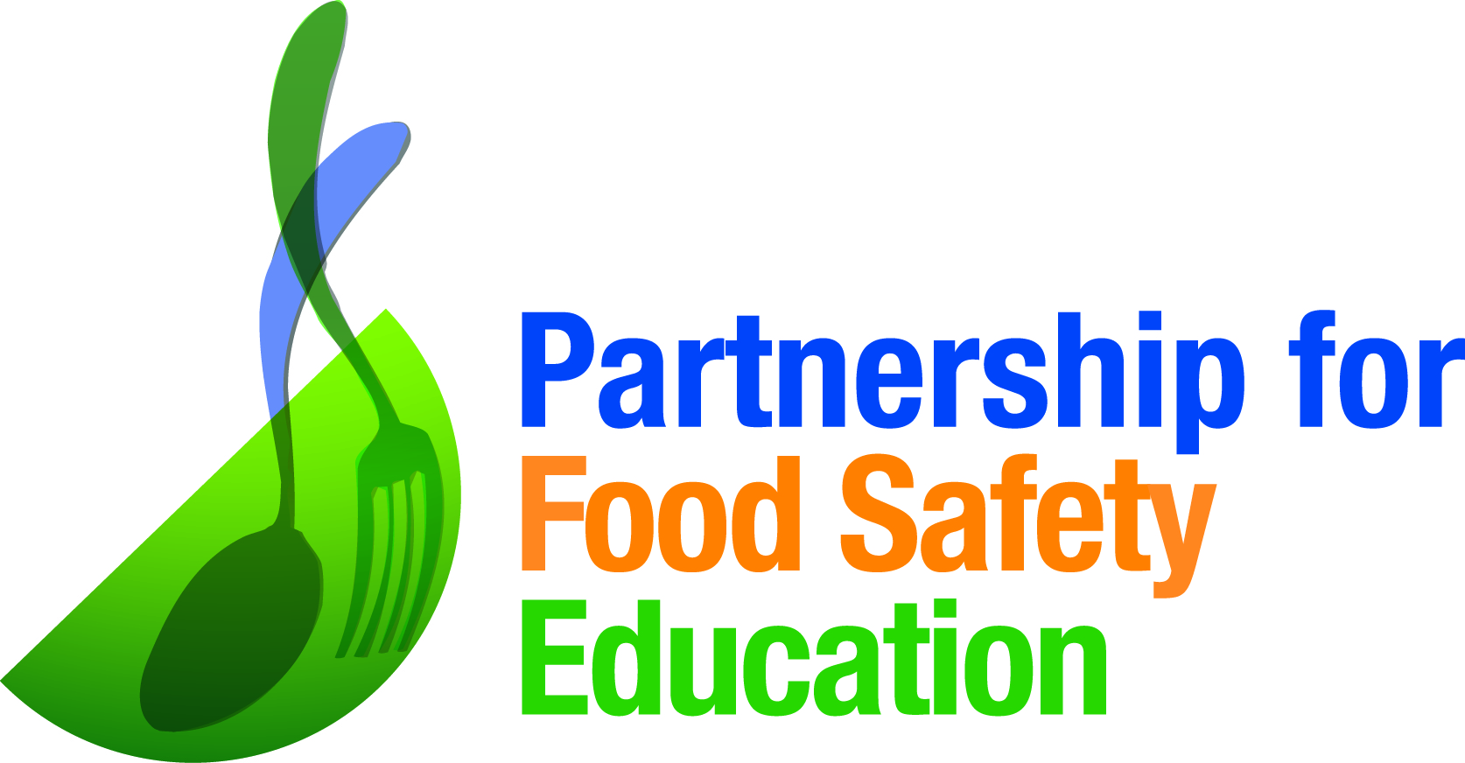

BACFIGHTERS: GO 40 °F or BELOW
Press Outreach “How To” Action Guide
Your local media may be interested in developing stories about consumer health and wellness. You can play an important role in your community in advancing the Go 40 or Below messages. Use this guide to connect with your local media.

- Identify local media targets (print, broadcast and online) and confirm email addresses

- Identify which media contacts are best for you to focus on for each campaign audience -- Older adults, Pregnant, Pregnant Hispanic

- Outreach Options:
- Media Contact E-blast:
  - Write brief introduction (option to use below)
  - Insert PDF of pitch (Older Adult, Pregnant or Pregnant Hispanic) in your email
  - If you are focusing on Older Adult coverage, be sure to include video link
  - Attach press release and infographic (downloadable here)
  - Copy and paste the media contact email addresses in the BCC “To” line (this way people who receive the email won’t see others who receive it)
  - Be sure to include your contact information, including phone number
  - Send

- Targeted Media Contact:
  - Write individual personalized emails (recommended for top tier targets) explaining the compelling case for the topic to be covered for the local audience
  - If sending for Older Adults coverage, include the video link
  - Attach the pdf pitch document
  - Attach press release and infographic.
  - Be sure to include your contact information, including your phone number
  - Send to individual target, addressing him/her specifically in the email

Options for Email Subject Line:
- Interview availability- important food safety message for area consumers
- GO 40 °F OR BELOW To Reduce Risk of Food Poisoning

Email Introduction (Please personalize as needed)

Good afternoon,

Maintaining a home refrigerator temperature at 40 °F or below is one of the most effective ways to reduce the risk of food poisoning. I’m proud to be a partner on the latest campaign from the Partnership for Food Safety Education -- GO 40 °F OR BELOW – which was launched to educate consumers about the fact that a cold refrigerator really helps keep food safe. .

Each year, about 48 million people in the US (1 in 6) experience food poisoning. . With GO 40 °F OR BELOW, the Partnership for Food Safety Education aims to change these statistics by empowering consumers with the knowledge and tools to reduce the risk of Listeriosis and other foodborne infections. Simple solutions like making sure the home refrigerator is set at40 °F OR BELOW and not keeping leftovers too long can make all the difference.

Please find more information attached/below.

I hope you will consider sharing this important news with <city / region or readers/viewers> and/or joining the conversation at #Go40orBelow. With your help, we can help reduce the number of illness and death caused by foodborne illness each year. Please let me know if I can provide anything additional.

Thanks,
<Your Name>

